Stage 1 Lab - Human vs AI: Building Your First
SmartCare Prototype
Learning objectives
• Create and run a simple Python file with basic input,output and processing statements
• Use lists, dictionaries and functions to enhance the Python file
• Build a small SmartCare appointment prototype.
• Use AI as a tutor rather than a replacement.
• Compare human-written and AI-generated code.
• Verify AI-generated code through execution and test inputs.
• Document a short AI-use reflection.
Files to create and commit in GitHub
stage01/
smartcare_v01.py
comparison.md
reflection.md
Ai_usage.md

Part A - Understand the Problem: AI OFF
SmartCare needs a small prototype that allows a receptionist to record patient appointments. Each appointment records patient name, practitioner name and appointment time.
What data must be stored?
Patients names, Practitioners names and appointment time.

What functions might be useful?
Main, record appointments and view records

What could go wrong?
Data is not saved properly and information is lost leading to the inability to have the appointment. (for example, the time of the appointment is lost so the practitioner doesn't know when to show up.)

What requirements are unclear?

Part B - Build a Human-Written Prototype: AI OFF
#task 1
# Create and run a simple Python file with basic input,output statements
print("Welcome to SmartCare: Community Clinic Appointment Booking System!")
# First Appointment
patient1_name = 'Alice Smith'
practitioner1_name = 'Dr. John Doe'
appointment1_time = '2024-07-20 10:00 AM'
print(f"Patient: {patient1_name} | Practitioner: {practitioner1_name} | Time:
{appointment1_time}")
# Second Appointment
patient2_name = 'Bob Johnson'
practitioner2_name = 'Dr. Jane Roe'
appointment2_time = '2024-07-20 11:30 AM'
print(f"Patient: {patient2_name} | Practitioner: {practitioner2_name} | Time:
{appointment2_time}")
#task1enhanced
# Use lists, dictionaries and functions to enhance the Python file
appointments = []
def book_appointment(patient_name, practitioner_name, appointment_time):
if not patient_name:
raise ValueError("Patient name cannot be empty")
appointment = {
"patient": patient_name,
"practitioner": practitioner_name,
"time": appointment_time
}
appointments.append(appointment)
def display_appointments():
if not appointments:
print("No appointments recorded.")
return
for appointment in appointments:
print(f"Patient: {appointment['patient']} | Practitioner:
{appointment['practitioner']} | Time: {appointment['time']}")
print("Welcome to SmartCare: The Clinical Appointment Booking System!")
book_appointment('Alice Smith', 'Dr. John Doe', '2024-07-20 10:00 AM')
book_appointment('Bob Johnson', 'Dr. Jane Roe', '2024-07-20 11:30 AM')
display_appointments()
^ Now, run both programs , and identify at least five limitations.
Limitation 1: No way to input more data without going into the code for either of the two codes.
Limitation 2: In the second upgraded code if one of the patient names is empty it spits out an error which stops the whole code. But if you remove the practitioners' name or the date it doesn't throw out any errors.
Limitation 3: Adding more appointments for the first non-upgraded code requires you to list each data point then print it, unlike the upgraded code where you just write a single line with all the data in it to make an appointment.
Limitation 4: neither code tests for duplicate appointments.
Limitation 5: Neither code saves its data anywhere it just prints it so once the code is changed all appointment history is lost.

Part C - Use AI as Tutor: AI ON (Use only UC approved GenAI Tool such
as Microsoft CoPilot)
Suggested prompt structure:
Act as a Python tutor.
I am learning introductory software technology.
Here is a small appointment-booking function.
1. Explain what the code does.
2. Identify three limitations.
3. Suggest improvements.
4. Do not rewrite the whole application.
5. Ask me two questions to test my understanding.

Here is the prompt i used
“I am learning introductory software technology.
Here is a small appointment-booking function.
1. Explain what the code does.
2. Identify three limitations.
3. Suggest improvements.
4. Do not rewrite the whole application.
5. Ask me two questions to test my understanding.

#task1enhanced
# Use lists, dictionaries and functions to enhance the Python file

appointments = []

def book_appointment(patient_name, practitioner_name, appointment_time):
if not patient_name:
raise ValueError("Patient name cannot be empty")
appointment = {
"patient": patient_name,
"practitioner": practitioner_name,
"time": appointment_time
}
appointments.append(appointment)

def display_appointments():
if not appointments:
print("No appointments recorded.")
return
for appointment in appointments:
print(f"Patient: {appointment['patient']} | Practitioner: {appointment['practitioner']} | Time: {appointment['time']}")

print("Welcome to SmartCare: The Clinical Appointment Booking System!")
book_appointment('Alice Smith', 'Dr. John Doe', '2024-07-20 10:00 AM')
book_appointment('Bob Johnson', 'Dr. Jane Roe', '2024-07-20 11:30 AM')
display_appointments()”

The output is in ai_usage.md

Part D - Generate an Alternative: AI ON
Ask AI to create a simple beginner-friendly Python function that stores patient name, practitioner name and
appointment time. Explicitly prohibit a database or GUI.

Here is the prompt i used
Can you please make me a beginner friendly python function that stores patient name, practitioner name and appointment time. Do not use database or GUI

The output is in ai_usage.md

Part E -

Compare Human and AI Versions

Question | Human version | AI version
Easy to understand? | Yes. Basic, short and easy. | Yes. Clear names and has comments explaining things.
Runs successfully? | Yes prints welcome messages and appointments. | Technically runs but the user cannot add any appointments.
Uses only required features? | Yes. Does not store anything not required. | Prints out messages like "Appointment added successfully.” which were not asked for.
Adds assumptions? | Assumes practitioner and time don't need to be validated. | Gives messages when the code runs successfully both of which were not in the prompt.
Handles errors? | Only checks patient name and raises an exception. | Checks all 3 fields and fails with a printed message and return instead of crashing.
Could I explain it? | Yes | Yes

Part F - Verify Behaviour
• Normal appointment
Wrote add_appointment('Alice Smith', 'Dr. John Doe', '2024-07-20 10:00 AM')
show_appointments()
And it outputted
Current Appointments:
Patient: Alice Smith | Practitioner: Dr. John Doe | Time: 2024-07-20 10:00 AM

• Blank patient name
Wrote add_appointment('', 'Dr. John Doe', '2024-07-20 10:00 AM')
show_appointments()
And got Error: Patient name cannot be empty.
No appointments found.

• Two appointments for the same practitioner/time
Wrote add_appointment('Jeff', 'Dr. John Doe', '2024-07-20 10:00 AM')
add_appointment('Lucy', 'Dr. John Doe', '2024-07-20 10:00 AM')
show_appointments()
And it outputted
Current Appointments:
Patient: Jeff | Practitioner: Dr. John Doe | Time: 2024-07-20 10:00 AM
Patient: Lucy | Practitioner: Dr. John Doe | Time: 2024-07-20 10:00 AM

There was nothing to detect that the same practitioner had 2 appointments at the same time

• Strange input such as patient_name=None or appointment_time=None
Wrote add_appointment(none, none, none)
show_appointments()
Outputted
Traceback (most recent call last):
File "C:\Users\rgrie\OneDrive\Documents\st1-assignment-2\week4\Ai_code.py", line 38, in <module>
add_appointment(none, none, none)
^^^^
NameError: name 'none' is not defined. Did you mean: 'None'?

Part G - Improve One Thing
Choose exactly one controlled improvement, for example: if not patient_name: raise ValueError("Patient name
cannot be empty")
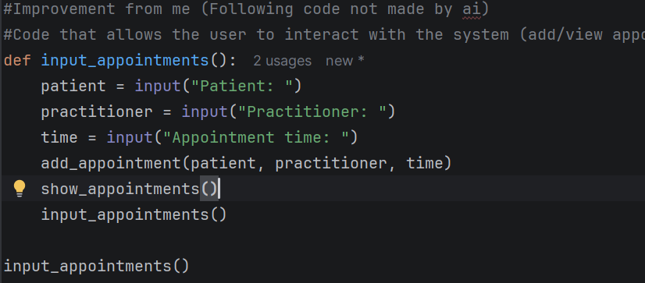
This code allows the user to interact with the system since they couldn't do that before

Part H - Reflection (150-250 words)

Before using AI I found the limitations for the code’s given to me including no way to input more data without going into the code for either of the two codes and in the second upgraded code if one of the patient names is empty it spits out an error which stops the whole code. But if you remove the practitioners' name or the date it doesn't throw out any errors. When I reviewed the human code the AI recommended adding conflict detection, use class based structure and validate time formats. When the AI made its code I verified it by running a set of tests as seen in part F of stage 1 lab like testing the outputs when Patient name is set to empty or if 2 appointments are made with the same dr and same time (Which the AIs code allowed despite not making sense for an appointment booking software to allow). The AI made the assumption that it needs to specifically mention when it has succeeded despite that not being in the prompt. I then improved the code by allowing the user to add appointments with input. I had to find the limitations of the codes, analyze them and improve them without the help of the AI.

Submission checklist [GitHub Commit]
• Python file runs.
• Comparison table completed.
• Normal and unusual inputs tested.
• AI assistance documented.
• Reflection completed.
• I can explain my code.

